Anatomy of Temporal Bone
Each temporal bone consists of four components: the squamous, petromastoid , tympanic parts and styloid process . The squamous part has a shallow mandibular fossa associated with the temporomandibular joint . The petromastoid part is relatively large ; its petrous portion houses the auditory apparatus and is formed of compact bone. In contrast, the mastoid process is trabecular and variably pneumatized. The tympanic part has the form of a thin and incomplete ring whose ends are fused with the squamous part. The styloid process gives attachment to the styloid group of muscles. Two canals are associated with the temporal bone. The external acoustic meatus, visible on the lateral surface, conveys sound waves to the tympanic membrane. The internal acoustic meatus, evident on the medial surface, conveys the facial and vestibulocochlear nerves (Standring et al , 2008).

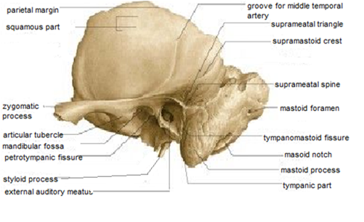
Fig.(1):showing the lateral view of temporal bone (Standering et al , 2008)

Squamous part
The squamous part liesanterosuperiorly and is thin and partly translucent. Its external temporal surface is smooth, slightly convex, and forms part of the temporal fossa to which temporalis is attached. Above the external acoustic meatus, it is grooved vertically by the middle temporal artery. The supramastoid crest curves backwards and upwards across its posterior part and gives attachment to the temporal fascia. The junction between the squamous and mastoid parts is approximately 1.5 cm below this crest, and traces of the squamomastoid suture may persist.The internal cerebral surface of the squamous part is concave and contains depressions which correspond to convolutions of the temporal lobe of the cerebral hemisphere. This surface is grooved by the middle meningeal vessels.The squamous part has a zygomatic process and a mandibular fossa.(Standring et al , 2008).

Tympanic part
The tympanic part of the temporal bone is a curved plate below the squamous part and anterior to the mastoid process. Internally it fuses with the petrous part and appears between this and the squamous part, where it is inferolateral to the auditory orifice. Behind, it fuses with the squamous part and mastoid process and is the anterior limit of the tympanomastoid fissure(Anson and Donaldson, 1992). Its concave posterior surface forms the anterior wall, floor and part of the posterior wall of the external acoustic meatus. The quadrilateral concave anterior surface is the posterior wall of the mandibular fossa and may contact the parotid gland. Laterally , the upper border is fused with the back of the postglenoid tubercle and medially , it forms the posterior edge of the petrotympanic fissure. The inferior border is sharp, and splits laterally to form, at its root, the sheath of the styloid process (vaginal process). Centrally, the tympanic part is thin, and is often perforated.(Glasscock and Shambaugh, 2010).
.
Petrous part :
It has a base, apex, three surfaces (anterior, posterior and inferior) and three borders (superior, posterior and anterior).The base correspond to the part that lies on the base of the skull and is separated from the squamous part by a suture. The apex is angled between the posterior border of the greater wing of the sphenoid and the basilar part of the occipital bone. It contains the anterior opening of the carotid canal and limits the foramen lacerum posterolaterally.(Norton and Netter, 2013).
The anterior surface show a trigeminal impression ,the arcuate eminence which is raised by the superior (anterior) semicircular canal. Between the squamous part laterally and the arcuate eminence medially ,the anterior surface is formed by the tegmen tympani . The posterior surface show the opening of the internal acoustic meatus . A small slit leading to the vestibular aqueduct lies behind the opening of the meatus. The subarcuate fossa lies above these openings. The irregular inferior surface show a quadrilateral area for attachment of levatorpalati and the cartilaginous pharyngotympanic tube. Behind this region is the carotid canal, and behind the opening of the canal is the jugular fossa. (Standering et al , 2008).

Mastoid part :
The mastoid part is the posterior region of the temporal bone and has an outer surface roughened by the attachments of the occipital belly of occipitofrontalis and auricularis posterior muscles. A mastoid foramen, of variable size and position, and traversed by a vein to the sigmoid sinus and a small dural branch of the occipital artery, frequently lies near its posterior border. The foramen may be in the occipital or occipitotemporal suture; it may be parasutural (40–50% of crania); or may be absent.(Standering et al , 2008).
The mastoid part projects down as the conical mastoid process, and is larger in adult males. Sternocleidomastoid, splenius capitis and longissimuscapitis muscles are all attached to its lateral surface, and the posterior belly of digastric muscle is attached to a deep mastoid notch on its medial aspect. The occipital artery runs in a shallow occipital groove which lies medial to the mastoid notch (Standering et al , 2008).
The superior border of the mastoid part is thick and serrated for articulation with the mastoid angle of the parietal bone. The posterior border is also serrated and articulates with the inferior border of the occipital bone between its lateral angle and jugular process . Anteriorly , the mastoid part is fused with the descending process of the squamous part .Below, it appears in the posterior wall of the tympanic cavity (Hiatt and Gartner, 2010).
Mastoid canals are the canals which are formed in the mastoid region of temporal bone which are located on the outer surface of the mastoid process, posterior and parallel to the petrosquamous suture ,anterior to the occipitomastoid suture and anteroinferior to the asterion .Perforated lateral wall of the mastoid canals are called as mastoid grooves (Hadimani and Bagoji, 2013).
There is a disparity in the literature about arterial branches lying in this area(outer surface of the mastoid region) . Hollinshead (1982) described an ascending arterial or auricular branch of occipital artery at this site . Glasscock and Shmbraugh (2010) noted an occipital branch of posterior auricular artery at this position , while Choudhry et al , (1996), reported asizeable branch of occipital artery and its accompanying vien at this site .
These vascular canals and grooves are of variable caliber and lengths ,and knowledge of them is very important for otolarygologist and neurosurgeons to avoid their injury which may result in sever bleeding. (Hadimani and Bagoji, 2013).

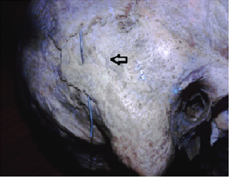
Fig.(2):showing both mastoid canal (metal wire ) and mastoid groove (arrow) in the mastoid region (Hadimani and Bagoji, 2013).
In recent years , the increasing use of transtemporal route for surgical procedure involving access to structure in the posterior fossa and the mastoid air cell system by neurosurgeons and otolaryngologists has increased the importance of structures in the mastoid area (Singh et al , 2004).
The internal surface of the mastoid process bears a deep, curved sigmoid sulcus for the sigmoid venous sinus: the sulcus is separated from the underlying innermost mastoid air cells by a thin lamina of bone.The posterosuperior part of the sigmoid sinus lies at the most superficial level .Inferiorly,the sinus lies gradually deeper making an anterior curve ,and crossing the tip of mastoid process at a level deep to the digastric crest (Tos, 1995).
During modified or radical mastoidectomy ,the bone of the sinus plate may be accidently damaged leading to sever venous bleeding .Thus ,the complications of perforating the sigmoid venous sinus during surgical mastoidectomy may possibly be avoided by the assessment of the depth of the sigmoid sinus plate from the suprameatal triangle (which was accepted as safe surgical approach during mastoidectomy) (Selman , 2010).

Surgical landmarks on the lateral surface of the mastoid part of temporal bone:
Mastoidectomy is one of the main surgical approaches for eradication of chronic ear disease. The operation has evolved enormously since the first attempt of opening the mastoid process in eighteenth century (Milstein , 1980).
Today mastoidectomies are classified into two groupes according to weather or not the posterior bony wall of external auditory meatus is removed (canal wall down and canal wall up procedure) .The surgical technique has been presented in two steps :the first in the lateral surface of the mastoid process ,and the second in medial deeper plane(Chole and Brodie, 2006).
The stepwise feature of the mastoidectomy makes it mandatory to know the relationship of the surface landmarks with landmarks in deeper location.Furthermore,there is a need to examine the variability in these surgical landmarks since the anatomical relationships inside the temporal bone might vary between individuals (Aslan et al , 2004 and newlands et al , 2006).
The lateral surface of the mastoid process show the following landmarks; the upper posterior angle of the meatus is usually marked by a small spine (the suprameatal spine of Henle) , this spine is commonly taken as a guide to the antrum which generally lies directly inward from it (Glasscock and Shambaugh, 2010). There is ashallow depression 1cm posterior to this spine with the cortex is perforated by numerous blood vesseles.This is the fossa mastoidea or cribriform area (suprameatal triangle) which is accepted as asafe surgical approach in mastoidectomy.(Bhargava et al , 2005).

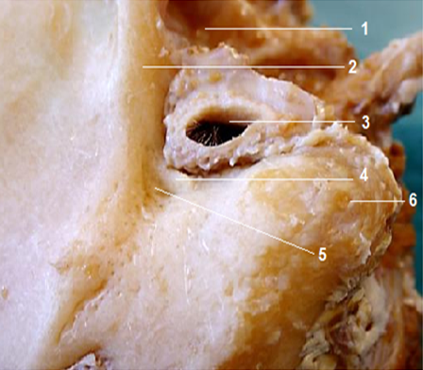

Fig. (3 ):Surface markings for mastoidectomy : Tempromandibular joint (1); root of zygoma (2); external ear canal (3); suprameatal spine (4); Macewen’s triangle (5) ; mastoid tip (6); Fagan , 2014))

On the lateral surface of the mastoid process ,the remnant of petro squamous suture may be present within the mastoid cells .This suture sometimes persistt as adistinct partition ,extending upward to the antrum and is known as the korner's septum ( Glasscock and Shambaugh, 2010).
The supramastoid crest arises from the temporal squama just above the external acoustic meatus as a blunt crest .It extended posteriorly then angulate posterosuperiorly forming the temporal line which is of great surgical importance as it helps the surgeons to determine the base of middle cranial fossa (Turgut et al , 2003).
Mastoid air cell system:
The mastoid air cell system represent a more or less extensive system of interconnecting airfilled cavities arising from the wall of mastoid antrum and the wall of the middle ear (Cinamon, 2009).The pneumatized spaces of the temporal bone are classified into five different regions ;the middle ear region, mastoid region, perilabrynthine region ,petrous apex region and accessory regions.(Sethi et al , 2006).
Mastoid region is subdivided into three compartments :mastoid antrum,central mastoid tract and the peripheral mastoid area .The mastoid antrum lies superiorly at the level of epitympanum and internal auditory canal .The antrum communicate with the epitympanum via the aditus and extend downward and laterally into the direction of the mastoid tip forming the space called central tract (Park ,et al., 2000).
The cells of the central mastoid tract include :tegmental cells, posterosuperior sinodural cells,posteroinferior sinal cells and mastoid tip cells.The tegmental cells lies in the tegmen mastoideum above the mastoid antrum The sinodural air cells bounded by dural plate superiorly and sigmoid sinus inferiorly ,while the mastoid tip cells lies inferior below the central tract (Ahmet et al , 2004).
During the development of temporal bone ,the pneumatization process follow definite tracts .These tracts are posterosuperior cell tract ,posteromedial cell tract ,subarcuate cell tract ,perilabrynthine cell tract and the peripheral cell tract.These tracts communicate together and may help to understand spread of diseases in temporal bone (Lee et al , 2005).According to the pneumatization process,the mastoid region may be classified into three types :sclerotic mastoid (abscent pneumatization),diploic mastoid (partial pneumatization)and pneumatic mastoid(complete pneumatization) ,(Swartz and Loevner, 2009).
The mastoid air cell system is an important contributer to the physiology of the middle ear.One of the main function of this system is that the mastoid works as an air reservoir to compensate for pressure variations in the middle ear together with eustachian tube.(Marco et al, 2013) and (Alper et al , 2011).
It is possible that the mastoid air cells, or, in general, every kind of mucosa contained in the middle ear , would act to create a quite constant negative pressure to obtain favorable compliance and impedance conditions in the middle ear to hear and transmit high frequency sounds and ultrasounds (Alicandri,et al., 2012).
The middle ear can be anatomically and functionally subdivided into two communicating airspaces, the anterior tympanum and the posterior mastoid air-cell system (MACS). The tympanum is essentially a large air-cell that contains the middle ear ossicles and functions as the peripheral transducer organ for hearing. In contrast, the MACS is a multiple partitioned, cellular, air-space that increases middle ear volume and surface area, but does not participate directly in sound transduction. While the function of the MACS is debated., numerous studies show that MACS volume is indirectly related to the predisposition of the middle ear to certain pathological conditions including cholesteatoma and otitis media. One hypothesis advanced to explain this relationship is that the MACS functions as a middle ear gas reserve such that middle ear with larger MACS require less frequent eustachian tube openings to maintain near-ambient total pressure (Doyle ,2007) and (Gaihede et al ., 2010).

Acording to Magnuson ,the mastoid air cell works as a thermal insulator to protect the middle ear against temprature fluctuations (Magnuson , 2003).
Mastoid antrum:
The mastoid antrum located in the upper and front part of the mastoid bone .It is filled with air and lined by a prolongation of mucous membrane of tympanic cavity through which it communicates (Moore, 1992).
Anterosuperiorly , the antrum is continous with the epitympanum through aditus ad antrum .The superior wall of the antrum is the tegmen tympani ,inferiorly the mastoid process ,medially ;the labyrinth and anteriorly, the lateral semicircular canal.(Tos, 1995).
The size of the mastoid antrum varies considerably ;in small sclerotic mastoid with no pneumatization ,the antrum is quite small .While in well pneumatized mastoid ,it can be voluminous. In ear with no korner's septum ,there is no border between larg mastoid cells and the antrum and in such cases the antrum is huge (Swarts et al , 2011).
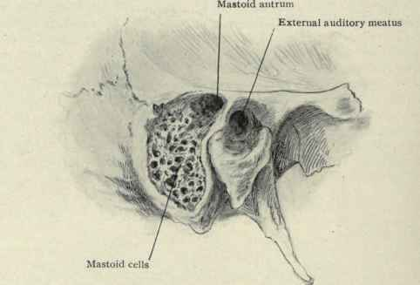
Fig( 4): The mastoid antrum is exposed by chiselling through the suprameatal triangle .The mastoid cells are exposed by chiselling off the surface of mastoid process (Davis, 2005)
Korner's septum:
This septum represents the site of embyological fusion between the squamous and the petrous parts of temporal bone .Between these two parts there is a sutural line that is normally obliterated but occasionally , a plate of a bone persist which is called korner's septum. When this septum is present it divides the mastoid process into superficial (squamous) portion and deep (petrosal) portion ,both are open separately into the mastoid antrum and may give false impression of reaching the antrum ( Glasscock and Shambaugh,2010).
In well pneumatized mastoid process ,this septum is hardly recognizable But if the squamous portion is poorly pneumatized or sclerotic ,there may be great difficulty to reach the mastoid antrum and the korner's septum must be penetrated to reach the deeper air cells of the mastoid bone (Goksu et al., 1997).The korner's septum shoud be considered if there is dificulty in approaching the antrum or if the antrum is small and constricted or if the antrum has an anomalous position (Tos , 1995).

Blood supply of the mastoid part of temporal bone:
Occipital artery:
The occipital artery arises in the neck from the external carotid artery . It runs in a groove on the temporal bone, medial to the mastoid process. Accompanied by the greater occipital nerve, the occipital artery enters the back of the scalp by piercing the investing layer of deep cervical fascia that connects the cranial attachments of trapezius and sternocleidomastoid. Tortuous branches run between the skin and the occipital belly of occipitofrontalis, anastomosing with the opposite occipital, posterior auricular and superficial temporal arteries as well as with the transverse cervical branch of the subclavian artery. These branches supply the occipital belly of occipitofrontalis and the skin and pericranium associated with the scalp as far forward as the vertex. The artery may give off a meningeal branch which traverses the parietal foramen (Standring et al , 2008).
The course of the occipital artery is divided into three segments. The first, or digastric segment, extends from the origin to the exit off the occipital groove of the mastoid process. The second segment, or suboccipital, extends from the occipital groove to the superior nuchal line. The third, or terminal segment, corresponds to the subgaleal segment just above the superior nuchal line up to the vertex. Two main descending branches of the second segment or suboccipital are identified. The superficial descending branch (SDB) runs between the spleniumcapitis and semispinaliscapitis while the deep descending branch (DDB) enters the suboccipital triangle. Anastomotic vessels between one of these two descending branches and branches of the vertebral artery are found(Alvernia et al , 2006).

Posterior auricular artery :
The posterior auricular artery arises in the neck from the external carotid artery, and ascends between the auricle and mastoid process. It supplies the cranial surface of the auricle via its auricular branch, and the occipital belly of occipitofrontalis and the scalp behind and above the auricle via its occipital branch. The posterior auricular artery anastomoses with the occipital artery. (Standring et al , 2008).
Suprameatal spine and suprameatal triangle:
The suprameatal spine (Henle spine)is a projection of variable prominence at the posterosuperior aspect of external auditory meatus(E.A.M).it is commonly taken as a guide to the mastoid antrum which generally lies directly inward from it (Glasscock and Shambaugh, 2010).

The shape and position of the suprameatal spine vary .There are four variants of suprameatal spine :variant 1; it is small and smoothly contoured and in these cases the tympanic bone forming the anterior wall of EAM and the styloid process are very short.Variant 2; the suprameatal spine is a sharp and elongated crest and in these cases the tympanic bone is thin and straight plate that provide agood access to the middle ear and the styloid process is short.Variant 3; there is no true spine ,only aconical shaped depression and the styloid process is relatively long .The anterior part of temporal bone is thick and prominent.Variant 4 ; the suprameatal area is smooth and there is no suprameatal crest .the tympanic part is prominent and the styloid process is very long (Tos, 1995). Aslan et al, 2004 describes three types of suprameatalspine :triangular type, crest type or absent spine.

Posterior to the suprameatal spine ,a group of small holes in the mastoid cortex are occasionally seen and are escribed as cribriform area(fossa mastoidae).Small vesseles pass through these foramina to the mucosa of the underlying mastoid antrum .This cribriform area lies within the suprameatal triangle(Macewen's triangle),( Milton and Cousins , 1986).
The suprameatal triangle is identified by three lines :the first is the anterior end of the supramastoid crest (represent the superior border of the triangle),the second is the posterosuperior margin of EAM (this line passes through the suprameatal spine and represent the inferior border of the triangle).The triangle is completed by a line drawn perpendicular to the first line and tangantial to the second line ( Glasscock and Shambaugh, 2010).

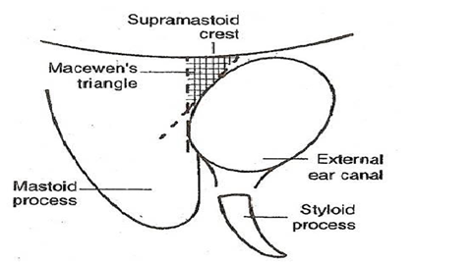

Fig.(5):Diagramatic illustration of suprameatal triangle (Mscewen's triangle), (Selman , 2010).

As the suprameatal spine represents the lower border of the suprameatal triangle ,it would be probably larg in size when the suprameatal triangle begins to develop early in fetal life . So ,a large suprameatal spine and deep suprameatal triangle can be accepted as a sign of early embriological development (Peker et at , 1998).

The posterior root of zygomatic process is divided into three parts : supra articular crest in front,and the supramastoid and the suprameatal crest behind. The suprameatal crest which forms the superior border of the suprameatal triangle represents the base of middle cranial fossa and the angulation of dura matter at that point (Turgut et al , 2003).
The suprameatal triangle is an important surgical landmark as the mastoid antrum lies medially to it at a depth of approximatly 1.25 cm ,so it is of a great surgical importance for surgical approaches to the middle ear and mastoid antrum (Standring et al , 2008).
Development of mastoid part of temporal bone
The membranous portion of the skull is derived from the neural crest cells and para axial mesoderm .Mesenchyme from these two sources invests the brain and undergoes intramembranous ossification .The result is formation of membranous bone which is characterized by the prescence of needle like bone specules .These specules progressively radiate from primary ossification centre toward the periphery and with further growth ,the membranous bone enlarges by apposition of new layers on the outer surface and by simultaneous osteoclastic resorption from the inside (Sadler, 2012).
The cartilagenous neurocranium of the skull initially consists of a number of separate cartilages .Those that lies in front of the rostral limit of the notocord are derived from the neural crest cells .They form the prechordal chondrocranium .Those that lie posterior to this limit arise from the occipital sclerotomes that are formed by paraaxial mesoderm and from the chordal chondrocranium .The base of the skull is formed when these cartilages fuse and ossify by endochondral ossification (Sadler, 2012).
The mastoid bone develops from two components :the squamous part arises in the mesenchyme at the 8th week of fetal life and it forms the anterosuperior part while the petrous part develops from the cartilaginous epiotic centre at 5-6th months at fetal life and it forms the postero inferior part by one year of age .These are demarkated on the external surface as the petrosquamous suture and is directed downward and forward into the mastoid process (Mclachlan ,1994).
The junction between these two components of temporal bone is often separated by a heavy plate of bone in many adults ,which is refered to as korner's septum or a false bottom and it is a remnant of the petrosquamous suture (Ahmet et al , 2004).
In adult skull ,the petrosquamous suture may be not distinguishable on the surface of the mastoid bone or seen as a series of irregular depressions or well marked fissures (Hadimani and Bagoji, 2013).
The ascending branch of the occipital artery ,which lies on the developing petromastoid in foetal life ,is likely to be buried by the ossifying squamotemporal bone or trapped between the two growing bones (Hadimani and Bagoji, 2013).
By the begining of the 4th month,the squama project posterior to the tympanic ring forming the lateral squamous portion of the mastoid ;the roof of EAM and the lateral wall of the antrum .While the medial portion of the mastoid develops the periosteal layer of the bony labyrinth is invaded by the air cells. The external petrosquamous fissure marks the junction between the petrosa and the squama and generally disappears by the 2nd year of life (Glasscock and Shambaugh, 2010).

The antrum ; alateral extention of the epitympanum ,starts to form at about 22 week and well developed by 35th week of gestation .the mastoid air cells develop as an outgrowth of the antrum.Epithelial buds from the tympanic cavity and the antrum extend to the adjacent areas of temoral bone after osteoclastic resorption of the bone or differentiation of bone marrow into mesenchyme .Thus, the mastoid buds from the antrum which penetrate the temporal bone ,giving rise to the mastoid air cells (Bernard,etal.2012).
At about 34th weeks of gestation ,pneumatization of mastoid may only just have started and this progresses during infancy and childhood .As the mastoid grow ,the antrum shrinks in size relatively and assume more medial position .when the antrum is completely formed in place ,the ventrolateral wall continue to grow untill puberty ,giving rise to the mastoid bone.(Allam , 1969).
The suprameatal triangle and spine begin to develop at the end of the first year,but traces may be observed at birth .Since the suprameatal triangle and spine nearly complete their development in early adolescence,no changes in these structure have been repoerted in adult temporal bone (Peker et al , 1998).
Postnatal development of mastoid part of temporal bone
The postnatal growth of mastoid can be seen in length ,width and depth .it is controled by two principal forces :the first is external which is caused by traction of the muscles of the neck mainly sternocleidomastoid muscle .The second is internal and consist of progression of the buds and expantion of tubotympanic epithelium following the resorption of the embryonic mesenchyme(Bernard et al , 2012).
Growth of the mastoid seems to be controled by many factors such as:heridatery,nutrition,environment ,gas exchange and frequency of infection (Ahmet et al , 2004).
In the neonate,the squamous part is large in comparison to that of the adult and the mastoid process is essentially non existing and the relative position of the temporal bone is inferolateral in comparison with the temporal bone of the adult .The facial nerve,in abscence of the mastoid process ,exists the stylomastoid foramen to emerge on the lateral surface skull so it is liable to injury if a standard postauricular incision is performed (Glasscock and Shambaugh, 2010 and Sinnatamby , 2011).
In the neonate, the petrous and squamous parts of the temporal bone are usually partially separated by the petrosquamous fissure which opens directly into the mastoid antrum of the middle ear. The fissure closes in 4% of infants during the first year, but it remains unclosed in 20–40% up to the age of 19 years: it is a route for the spread of infection from the middle ear to the meninges (Standering et al , 2008).
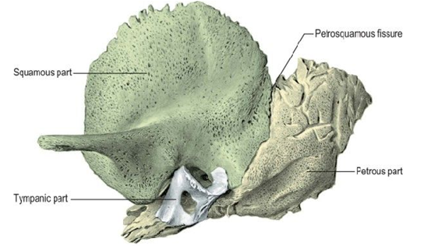
Fig.(6):Left temporal bone at birth (Standering et al , 2008).
After the first year of life ,the mastoid process begins development both laterally and inferiorly ,with the mastoid tip deriving from the petrous portion of the mastoid .Similarly ,the tympanic ring extends laterally completing the formation of the bony EAM and the sheath of the styloid process .With these changes in the mastoid and the tympanic bone ,the lateral aspect of the temporal bone is vertically oriented and the facial nerve is burried beneath the protective barier of the mastoid process (Glasscock and Shambaugh, 2010).
The Postnatal development of the mastoid is neither uniform nor symmetrical ,however it is obvious that the general morphology show that after an accelerated growth of the mastoid during the first 2 years of life ,the development continues relatively more progressive in the child and the teenager (Bernard et al , 2012).
The development of the mastoid process leads to creation of high number of mastoid cells that vary greatly in size which are grouped around the antrum. The external surface of the mastoid never relates to the width of contained air cell system ,so very small mastoid can be well pneumatized mastoid (Allam, 1969).
Ossification of temporal bone:
The four temporal components ossify independently.The squamous part is ossified in a sheet of condensed mesenchyme from a single centre near the zygomatic roots, which appears in the seventh or eighth week in utero. The tympanic part is also ossified in mesenchyme from a centre identifiable about the third month; at birth it is an incomplete tympanic ring, deficient above, its concavity grooved by a tympanic sulcus for the tympanic membrane. The styloid process develops from two centres at the cranial end of cartilage in the second visceral or hyoid arch: a proximal centre for the tympanohyal appears before birth, and another, for the distal stylohyal, appears after birth. The tympanic ring unites with the squamous part shortly before birth, and the petromastoid fuses with it and the tympanohyal during the first year (standering et al., 2008).
A total of six group of ossification centers appear in the petrous part during 5th fetal month, and they form the petrous bone at 6th fetal month. The first- ossification center to appear is just above the round window, and the second is on the ampulla of anterior semicircular canal. Other ossification centers are observed between the cochlea and semicircular canals, on the brim of internal acoustic porus, on the superior surface of the petrous apex, and on the summit of posterior semicircular canal (Kida , 1996).
Once ossified, the tympanic cavity, mastoid antrum and the posterior end of the pharyngotympanic tube become surrounded by bone. The petrous part forms the roof, floor and medial wall of the cavity, while the squamous and tympanic parts, together with the tympanic membrane, form its lateral wall (Standering et al., 2008).

